**Who We Are and What We Do**

SETHEO is a full-service engineering, construction, environmental and consulting solutions firm. Our multidisciplined staff includes engineers, architects, construction experts, planners, estimators, economists, technicians and scientists, representing virtually all design disciplines. We plan, design, permit, construct and manage facilities, with one mission in mind:   
**Producing the best services for our clients.**

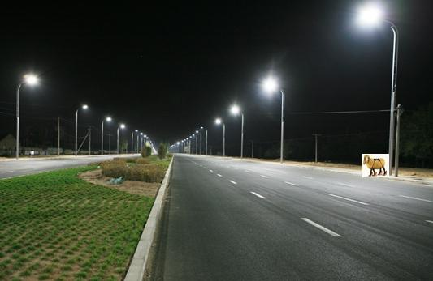

**Our History**

SETHEO was founded in … in South Africa as a general contractor offering services such as site analysis, feasibility studies and preliminary studies. Since then, the company has grown into a multi-location, full service engineering firm with offices in Nigeria, Congo and the United States of America.

Adhering to our original objective of “helping our clients succeed,” SETHEO continues to provides excellent electrical, civil, mechanical, building and consulting services to a wide range of clients including state and local government, blue chip construction companies, land and property developers and allied medical companies.

**Our Mission Statement**

Our mission is to be the best premier provider of general industrial construction, electrical, mechanical and civil services to our clients.